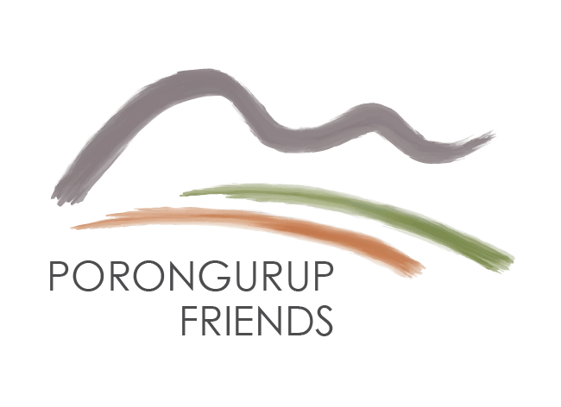
Friends of the Porongurup Range Inc
ABN 23 239 880 019

PO Box 514
Mt Barker WA 6324

www.porongurup.org.au
APPLICATION FOR MEMBERSHIP

Name ____________________________________________________________________________________________

Name ____________________________________________________________________________________________

Address ________________________________________________________________________________________

Postal address (if applicable) ______________________________________________________________________

Email address______________________________________________________________________________________

Email address______________________________________________________________________________________

Phone _______________________________ mobile _______________________________________________

Phone _______________________________ mobile _______________________________________________

Annual membership: Individual: $10.00 - Family: $20.00 (including children under 18 yrs)

An invoice will be sent to you after the application has been processed.

I/we agree to abide by Models Rules/Constitution of the Friends of the Porongurup Range Inc

Signature of applicant_____________________________________________ date____________________________

Signature of applicant ___________________________________________ date____________________________

____________________________________________________________________________________________________________________________________________________________________________________________________________________

For office use only

Two existing members of FOPR to complete section below:

I, _______________________, as a Member of the Friends of the Porongurup Range, Inc. nominate

the applicant/s for membership of the Association.

Signature of Member _____________________________________ date_________________________

Signature of seconder _____________________________________ date_________________________

Please return this form to Friends of the Porongurup Range, P O Box 514, Mt Barker WA 6324 or
Email: friends@porongurup.org.au
202110 30

